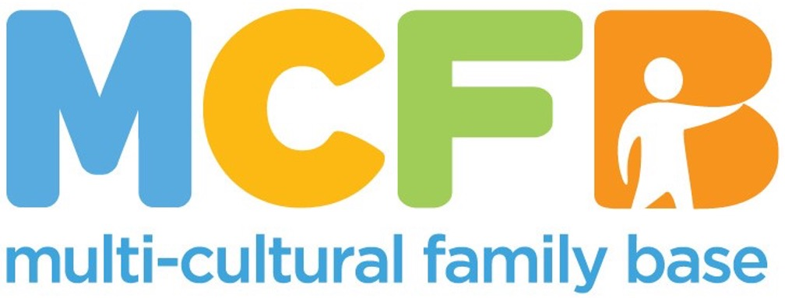
JOB PACK

This pack offers information on the role description and on our organisation. In order to apply, please complete the attached Application Pack.

ABOUT THE MULTI-CULTURAL FAMILY BASE
MULTICULTURAL FAMILY BASE is a unique, community based social work centre based in Edinburgh. Approximately 50% of our workforce are from a BAME background.
The organisation’s key objective is to support ethnically diverse children and parents deal with important transition points - this can be the birth of a child, the move into primary school or the move to Edinburgh for families who are new migrants. In addition, we combine our service delivery with student learning by providing high quality and diverse placement opportunities for social work students from academic institutions across Scotland.
We are now seeking a qualified, skilled, and motivated individual to join our board.
A strong commitment to anti-oppressive practice and equal opportunities is essential. The posts require membership of the PVG Scheme.

For more information visit: www.mcfb.org.uk

ABOUT THE ROLE
Post Title: Volunteer Board Director
Time Commitment:

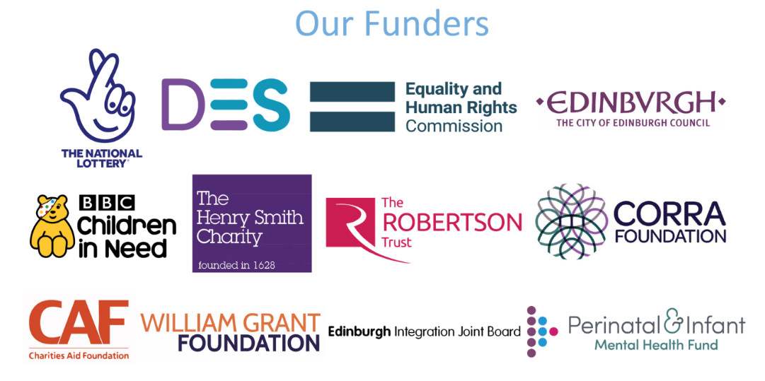

ROLE PURPOSE
All trustees share responsibility for ensuring a charity is well-run, complies with the law, and works to achieve its charitable purposes. Within the board, specific roles carry additional duties. They also play a large part in supporting the CEO and the organisation's strategic direction.

KEY RESPONSIBILITIES
- To support the governance of MCFB in alignment with its constitution and current best practices in Board Governance
- To attend Board meetings once a quarter and the Annual General Meeting (AGM) once a year.
- To keep organisational policies up-to-date in line with current legislation and guidance
- To support the CEO in management of institutional issues
- To guide the strategic vision of the organisation together with the CEO
- To sit on at least one of the Board sub-committees. Sub-committees support the board by focusing on specific areas of governance and operations.
  - The Finance Committee monitors budgets, cash flow, and financial planning to ensure the organisation's economic health.
  - The HR Committee addresses staff wellbeing, recruitment, performance management, and compliance with employment law.
  - The Anti-Racist Committee ensures that the organisation actively works to dismantle structural racism through policy, practice, and accountability.
  - The Risk Committee identifies and manages strategic and operational risks, including safeguarding, legal compliance, and reputational matters, helping to protect the charity's long-term sustainability.

Volunteers at MCFB are expected to carry out any other duties that support our service users’ wellbeing or are necessary to support the effective running of the organisation.

PERSON SPECIFICATION

Criteria | Essential | Desirable | Assessment Method
Education and Qualifications | * Secondary Level Education (HNC, HNQ, SVQ or equivalent)  * Relevant professional qualification e.g. social work/community work/community education | * Degree level Education  * Registration with appropriate professional body | *Application form
Experience and Knowledge | *Strong understanding of intersectionality, including the impact of racism on other areas of exclusion  * Relevant experience in working with ethnically diverse communities/groups in a community setting  * Having professional judgement about workload capacity  * Knowledge and understanding of the specific issues facing individuals and children from ethnically diverse communities in Edinburgh  * Experience of supporting other workers/ volunteers/ students | * Knowledge and understanding of child protection procedures  * Training in public protection, child protection (level 2), domestic abuse and/or coercive control or related  * Experience of interagency/ partnership working  *Prior board experience | * Application Form  * Interview  * References
Skills and Abilities | * Excellent communication skills (both written and verbal, including report writing)  * Confident user of IT  * Ability to communicate with young people and adults and build trusting relationships  * Ability to evaluate outcomes and report-writing skills  * Ability to work effectively with relevant professionals (education, social work, police, health)  * Proven ability to organise own workload  * Excellent team working skills  * Ability to maintain highest levels of confidentiality and maintain work records up-to-date | * Ability to speak a relevant community language  * Ability to maintain a professional attitude in challenging and emotive circumstances  * Creative and forward-thinking approach  * Ability to present publicly to a range of different audiences. | * Application form  * Interview  * References
Personal Qualities and Attitudes | * Strong ethical commitment to the aims and values of MCFB  * Commitment to anti-racist practice  * Commitment to working with empathy, impartially and in a confidential manner |  | *Application form *Interview  *References

Closing date: Open ended
Interview date: Open ended
Start Date: Open ended

To apply, please complete the application pack and email to hello@mcfb.org.uk or Ethelinda.Lashley-Scott@mcfb.org.uk

