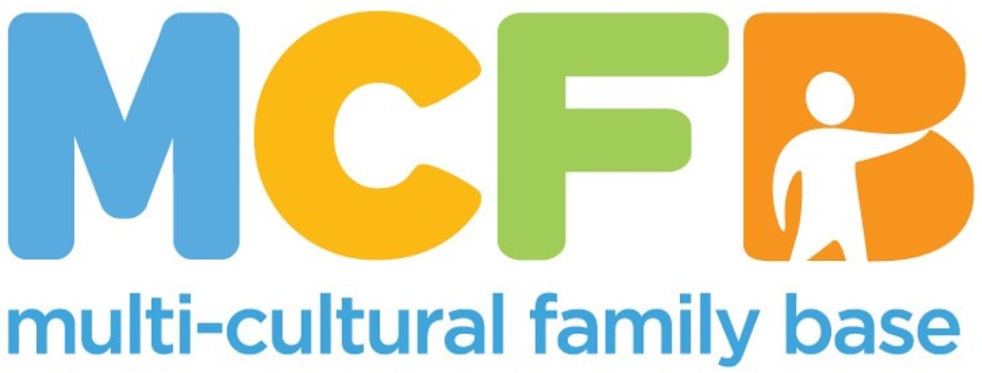
JOB PACK

This pack offers information on the role description and on our organisation. In order to apply, please complete the attached Application Pack.

ABOUT THE MULTI-CULTURAL FAMILY BASE
MULTICULTURAL FAMILY BASE is a unique, community based social work centre based in Edinburgh. Approximately 50% of our workforce are from a BAME background.
The organisation’s key objective is to support Black and Minority Ethnic individuals, children and parents deal with important transition points - this can be the birth of a child, the move into primary school or the move to Edinburgh for families who are new migrants. In addition, we combine our service delivery with student learning by providing high quality and diverse placement opportunities for social work students from academic institutions across Scotland.
We are now seeking a qualified, skilled and motivated individual to join our team.
A strong commitment to anti-oppressive practice and equal opportunities is essential. The posts require membership of the PVG Scheme.

For more information visit: www.mcfb.org.uk

ABOUT THE ROLE
Post Title: 8+ Project Worker
Hours: 21 hrs Per Week
Pay: £27,764.40 FTE (£16,658.64 pro rata)
Base: Some flexibility/Hybrid
50 Coburg Street, Edinburgh, EH6 6HE

Reports to: 8+ Project Leader

MCFB is an equal opportunities employer and welcomes applications from all sections of the community.

EMPLOYEE PACKAGE & BENEFITS
✓ Flexible Working & Family Friendly – We offer flexible working hours to accommodate families, childcare and caring responsibilities.
✓ Pension – All eligible staff are auto-enrolled in our Royal London pension scheme with a minimum 1.27% contribution from you and minimum 6.73% contribution from MCFB.
✓ Annual Leave - Annual leave entitlement is ample with 30 days and 12 mandatory holidays per calendar (pro-rated for part-time positions).

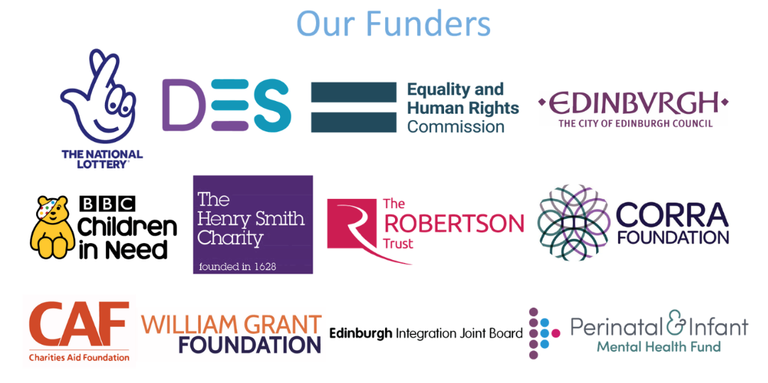

ROLE PURPOSE
To provide individual and group work interventions for vulnerable and disadvantaged ethnically diverse children who are experiencing challenges in the transition to High school in order to promote these children’s overall well-being and enable them to fulfil their potential.

KEY RESPONSIBILITIES
- To liaise with different settings in schools in order to identify ethnically diverse children who will be vulnerable and experience difficulty.
- To conduct initial assessments of needs and risks for children referred to the project
- To facilitate a group work programme for children within school / early years settings and at MCFB
- To carry key case worker responsibility for individual interventions with children
- To keep an overview of other individual work undertaken by social work students at MCFB
- To ensure that the needs and progress of all children are evaluated and recorded within case files and project records in accordance with MCFB’s Confidentiality and Recording Policy and other relevant policies
- To undertake assessments of children’s well-being at the beginning and end of interventions in order to measure the impact of the provision
- To maintain communication with the families of the children to promote their involvement in the project
- To work at all times in a respectful, collaborative and open way with children and families
- To build and maintain links with teachers, English as an Additional Language (EAL) staff, early years professionals and relevant staff from statutory and voluntary agencies
- To build links with other agencies providing services to black and minority ethnic children and families
- To signpost children and families to other agencies where appropriate
- To promote the work of MCFB and disseminate information about the 4 Corners (8+) Project
- In conjunction with the Project Leader to report on the progress of the project for funders and other relevant duties which may be necessary.

All employees at MCFB are expected to carry out any other duties that support our service users’ wellbeing or are necessary to support the effective running of the organisation.

PERSON SPECIFICATION

Criteria | Essential | Desirable | Assessment Method
Education and Qualifications | * Secondary Level Education (HNC, HNQ, SVQ or equivalent)  * Relevant professional qualification e.g. social work/community work/community education | * Degree level Education  * Registration with appropriate professional body | *Application form
Experience and Knowledge | *Strong understanding of intersectionality, including the impact of racism on experiences of HBA and domestic abuse.  *Understanding of how homophobia, biphobia, and transphobia impact LGBTQ+ people’s experiences of abuse and access to support.  * Relevant experience in working with ethnically diverse communities/groups in a community setting  * Having professional judgement about workload capacity  * Knowledge and understanding of the specific issues facing individuals and children from ethnically diverse communities in Edinburgh  * Experience facilitating group work with young people and adults  * Experience of supporting other workers/ volunteers/ students | * Knowledge and understanding of child protection procedures  * Training in public protection, child protection (level 2), domestic abuse and/or coercive control or related  * Experience of interagency/ partnership working | * Application Form  * Interview  * References
Skills and Abilities | * Excellent communication skills (both written and verbal, including report writing)  * Confident user of IT  * Ability to communicate with young people and adults and build trusting relationships  * Ability to engage with families and individuals referred to 8+ individually and in groups  * Group facilitation skills  * Ability to evaluate outcomes and report-writing skills  * Ability to work effectively with relevant professionals (education, social work, police, health)  * Proven ability to organise own workload  * Excellent team working skills  * Ability to maintain highest levels of confidentiality and maintain work records up-to-date | * Ability to speak a relevant community language  * Ability to maintain a professional attitude in challenging and emotive circumstances  * Full, clean UK driver’s license and access to own vehicle  * Creative and forward-thinking approach  * Ability to present publicly to a range of different audiences. | * Application form  * Interview  * References
Personal Qualities and Attitudes | * Strong ethical commitment to the aims and values of MCFB  * Commitment to anti-racist practice  * Commitment to working with empathy, impartially and in a confidential manner  * Willing to travel as required in order to deliver the service within the community |  | *Application form *Interview  *References

Closing date: 20th April 12.00
Interview date: 27th April (Afternoon)
Start Date: TBC

To apply, please complete the application pack and email to hello@mcfb.org.uk

